FACT:

Wastewater from roof cleaning can flow directly into our creeks, rivers and waterways.

Stormwater pollution – the effects of roof cleaning
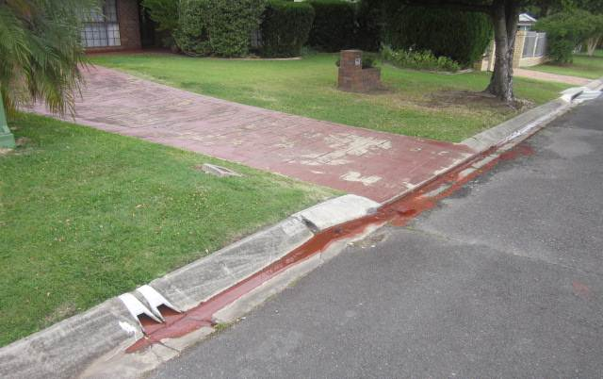
Roof and gutter downpipes connect directly to roadside gutters, stormwater drains and into our waterways. This means wastewater run-off from roof cleaning ends up in our creeks, rivers and the ocean. Pollutants, such as oxides, algae, paint flakes, concrete and sediment can kill seagrass, aquatic plants and marine life. By taking some simple precautions when cleaning and restoring roofs, you can help protect our waterways.

The Law
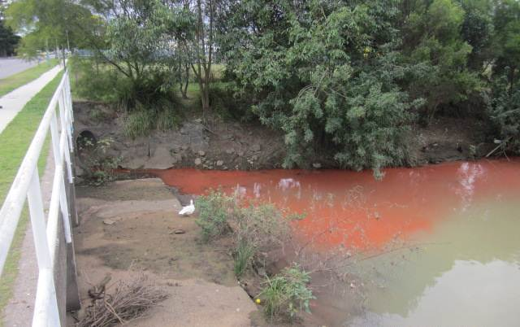
Allowing polluted wastewater to enter stormwater drains, roadside gutters or waterways is an offence under the Environmental Protection Act 1994 and may attract a fine to the value of 15 penalty units (individual) or 75 penalty units (corporation), or prosecution for multiple offences. See the Penalty Unit page for more information about penalty units.
In addition, using water blasters on asbestos cement roofs is illegal. Cleaning a fibro roof with a high pressure water blaster is illegal as it can destroy the roof surface, cause cement debris or asbestos to spray into the air, and result in widespread contamination.

Protecting the environment
We all share the responsibility of keeping our waterways clean and must ensure only clean water enters out stormwater systems. Below are some options that you could use when cleaning:
- if possible, disconnect downpipes and redirect wastewater to the garden, or to a holding tank for disposal by a licensed liquid waste disposal contractor
- if disconnecting downpipes is not possible, block the downpipe and feed the wastewater onto lawns or gardens
- hole may be drilled in the gutter or downpipe, the downpipe blocked (below the hole) and water diverted to garden beds. When complete, the hole can be plugged with a grommet
- use sandbags or a portable bund (a barrier to contain water) in the roadside gutter to protect stormwater drains from accidentals spills and runoff.

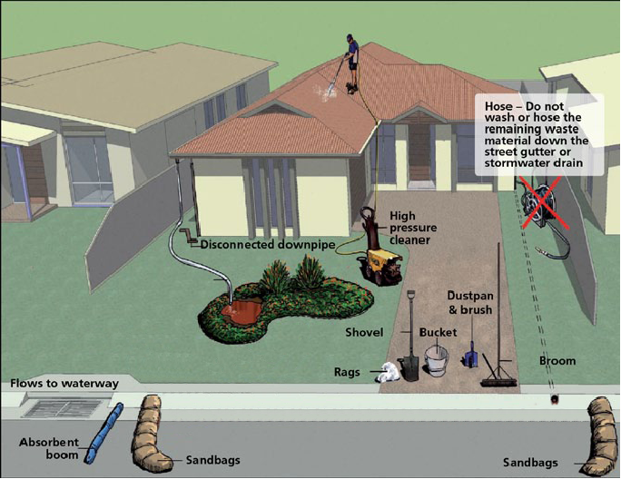

Artist impression of an acceptable setup for roof cleaning and restoration with downpipes disconnected and wastewater directed to a garden.

Other helpful tips
- Always keep a spill response kit, including a shovel, broom and rags, to clean-up residues nearby. Do not wash or hose remaining waste material into the stormwater drain.
- Keep cleaning times to a minimum.
- Be aware that wastewater from some houses may drain directly into a nearby waterway or subsurface stormwater pipe (not to a roadside gutter). In this case, downpipes must be disconnected and the water drained to a soakage area, such as, the garden or lawn.
- If wastewater does accidently drain to the stormwater gutter, remove all captured wastewater as soon as possible using a vacuum or bilge pump and direct to lawns or gardens, making sure no wastewater flows into the stormwater drain.
- Sandbags and portable bunds in the roadside gutter will capture accidental spills and runoff. They are not designed to hold wastewater from a full roof clean.
- For Business owners, please ensure all of your staff are aware of these requirements.

